
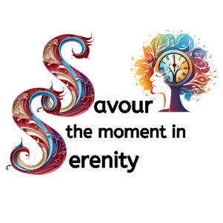

Menopause
Quiz

Are you Menopausal, Post Menopausal or Perimenopausal?
Do you have such a person in your life?
How much do you know about Menopause? Test your knowledge:

- What is the average duration of perimenopause, the stage leading up to menopause?
- Which type of exercise has been shown to help alleviate menopausal symptoms such as hot flashes and mood swings?
- What role do hormone levels play in the development of menopausal symptoms, and how do they change during menopause?
- True or False: Menopause only affects women's physical health and has no impact on cognitive function.
- How can mindfulness and relaxation techniques help women cope with the emotional and psychological changes associated with menopause?
- How does menopause impact bone density, and what can women do to prevent osteoporosis?
- Are there any lifestyle changes that can alleviate menopausal symptoms such as hot flashes and mood swings?
- Are there any dietary supplements or herbal remedies that are effective in managing menopausal symptoms?
- What impact does menopause have on sexual health and intimacy, and how can women address any challenges in this area?
- How does menopause affect cognitive function and mental health, and what strategies can women use to support their cognitive well-being?

You have the power to make changes in your life
To be the person you want to be
And live a healthy, fit and fulfilling life

You just need some knowledge to make informed decisions
Some tools and encouragement to be who you want to be
To make your way back to wholeness

